PROJECT REPORT: **SafeZone: Real-time Video Analytics for Industrial Safety**

**\*\*1. INTRODUCTION\*\***

1.1 Overview:

Industrial environments are notorious for their potential safety hazards and risks. Workers often operate in conditions where accidents can have severe consequences. This project aims to address these challenges by introducing a real-time surveillance system that employs advanced machine learning and deep learning techniques to monitor and detect potential safety hazards. By analyzing live video feeds, the system can identify unsafe behaviors and conditions in industrial settings. We are gonna capture a harmful event in industry like accidental _fire, fainting of any person due to any reason and on detection of smoke these are our trigger harmful points where we indicate with red bounding box, and the remaining classes are with green box ,we will be showing in a webapp using streamlit.

1.2 Purpose:

The purpose of this project is to create a robust real-time surveillance system that can significantly enhance industrial safety measures. The system will leverage state-of-the-art technologies to automatically identify and raise alerts for various hazardous situations, such as fires, smoke, and falls. By doing so, the project seeks to minimize the occurrence of accidents, thereby safeguarding workers' lives and improving overall safety protocols in industrial workplaces.

**\*\*2. LITERATURE SURVEY\*\***

2.1 Existing Problem:

Traditional safety approaches in industrial environments often rely on manual intervention and periodic checks, which might not be sufficient for promptly identifying potential hazards. Conventional surveillance systems mainly focus on monitoring, lacking the ability to actively recognize unsafe behaviours or conditions.

2.2 Proposed Solution:

The proposed solution involves the implementation of a real-time surveillance system that integrates machine learning and deep learning techniques. These technologies empower the system to analyze video streams, detect specific objects, behaviours, and anomalies, and trigger alerts when unsafe situations are identified. By adopting this approach, the system bridges the gap between passive monitoring and proactive hazard prevention.

**\*\*3. THEORETICAL ANALYSIS\*\***

3.1 Block Diagram:

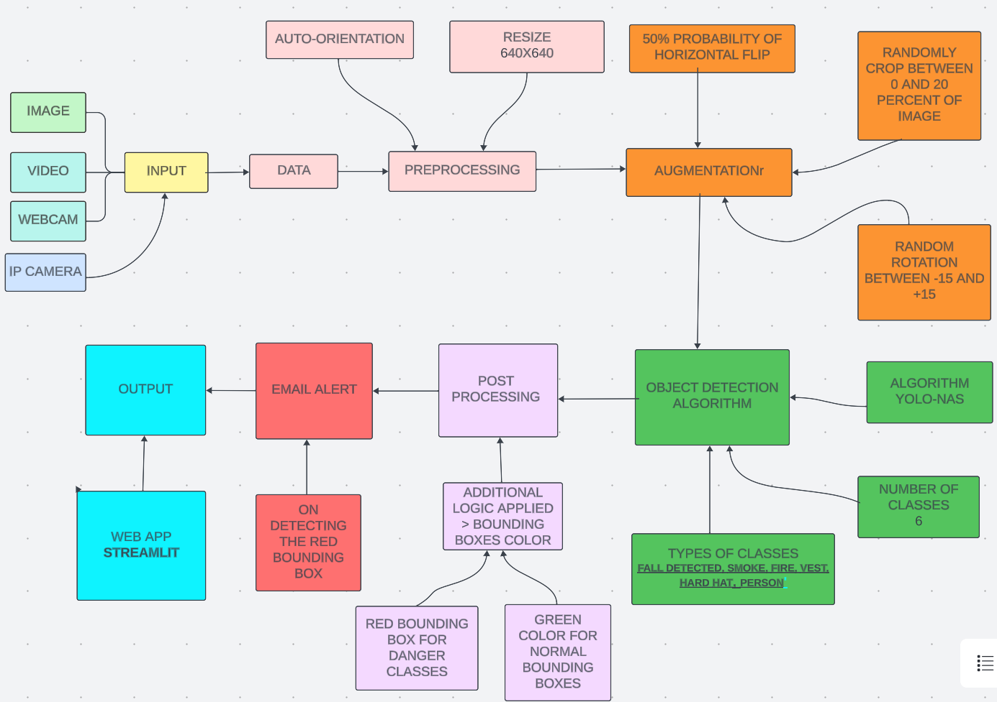

3.2 Hardware / Software Designing:

For this project, the hardware requirements include a standard computer with a compatible GPU for efficient deep learning processing. The software environment is set up using Anaconda, with essential packages like OpenCV for video processing, supergradients for enhanced image analysis, streamlit for webapp, and torch for implementing deep learning models which actually integrates the cuda and cuddn libraries so that gpu would be accessed to the code.

**\*\*4. EXPERIMENTAL INVESTIGATIONS\*\***

To validate the system's effectiveness, a dataset of approximately 823 images was collected and labeled. These images covered various hazardous scenarios, including fire, smoke, and fall incidents. The dataset was split into training, testing, and validation sets to train and evaluate the custom object detection models based on the YOLO-NAS architecture.

**\*\*5. FLOWCHART\*\***

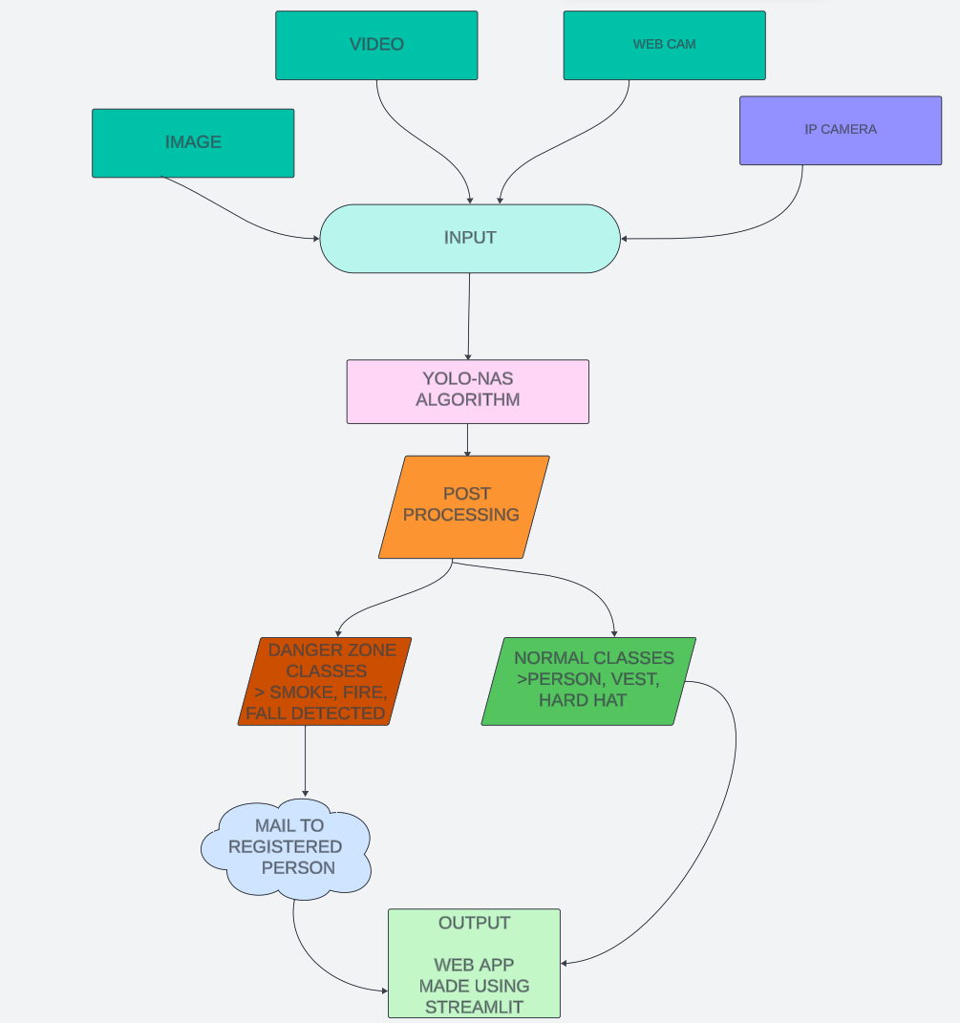

**\*\*6. RESULT\*\***

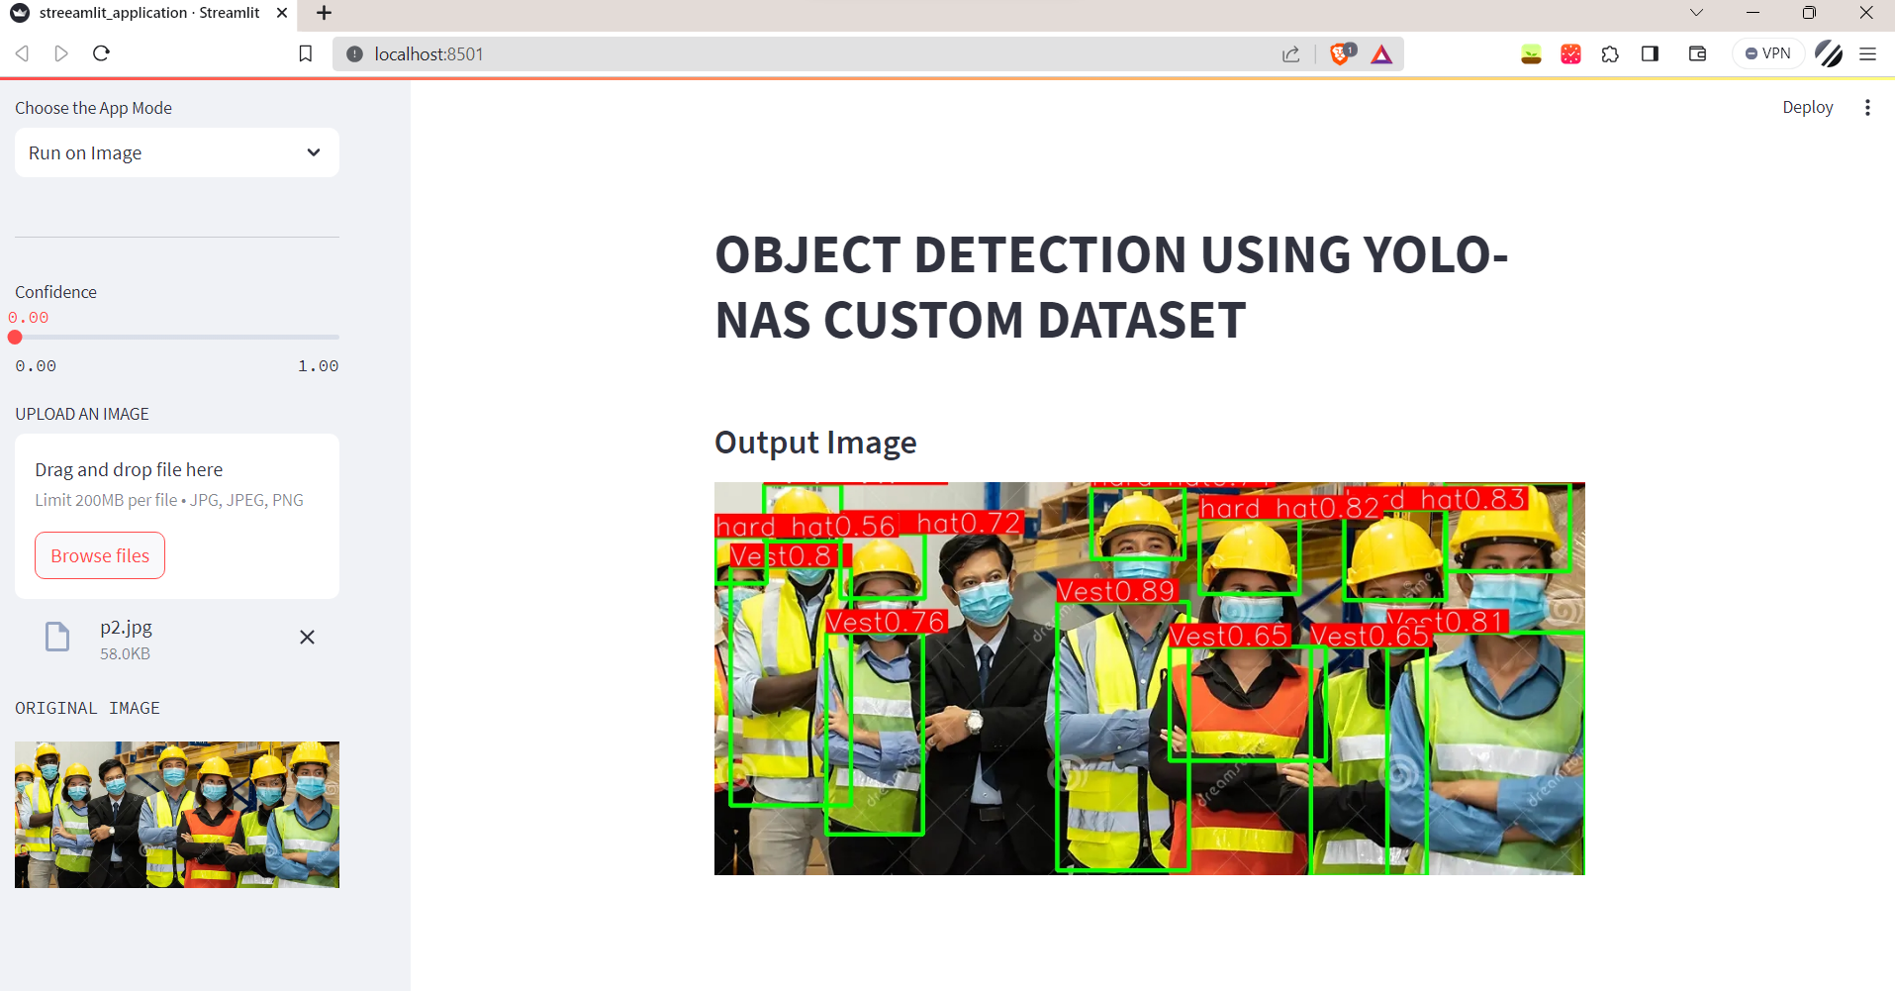

**The above shown is the webapp we made using streamlit.**

1. **In this image vest and hardhat are detected**

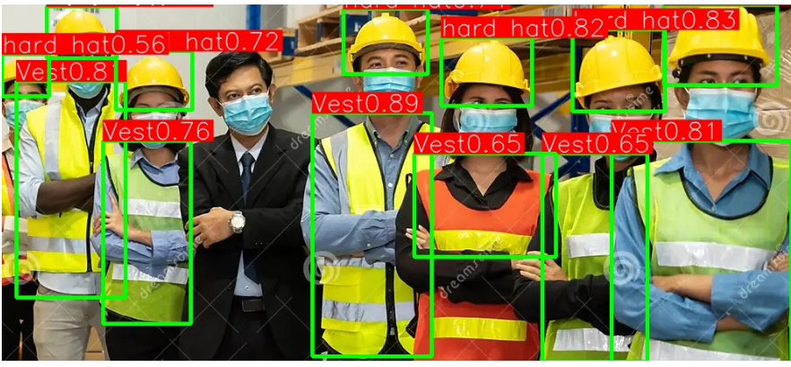

2_**)below shown left side is the original image that uploaded into webapp and the output is shown in the middle of the page**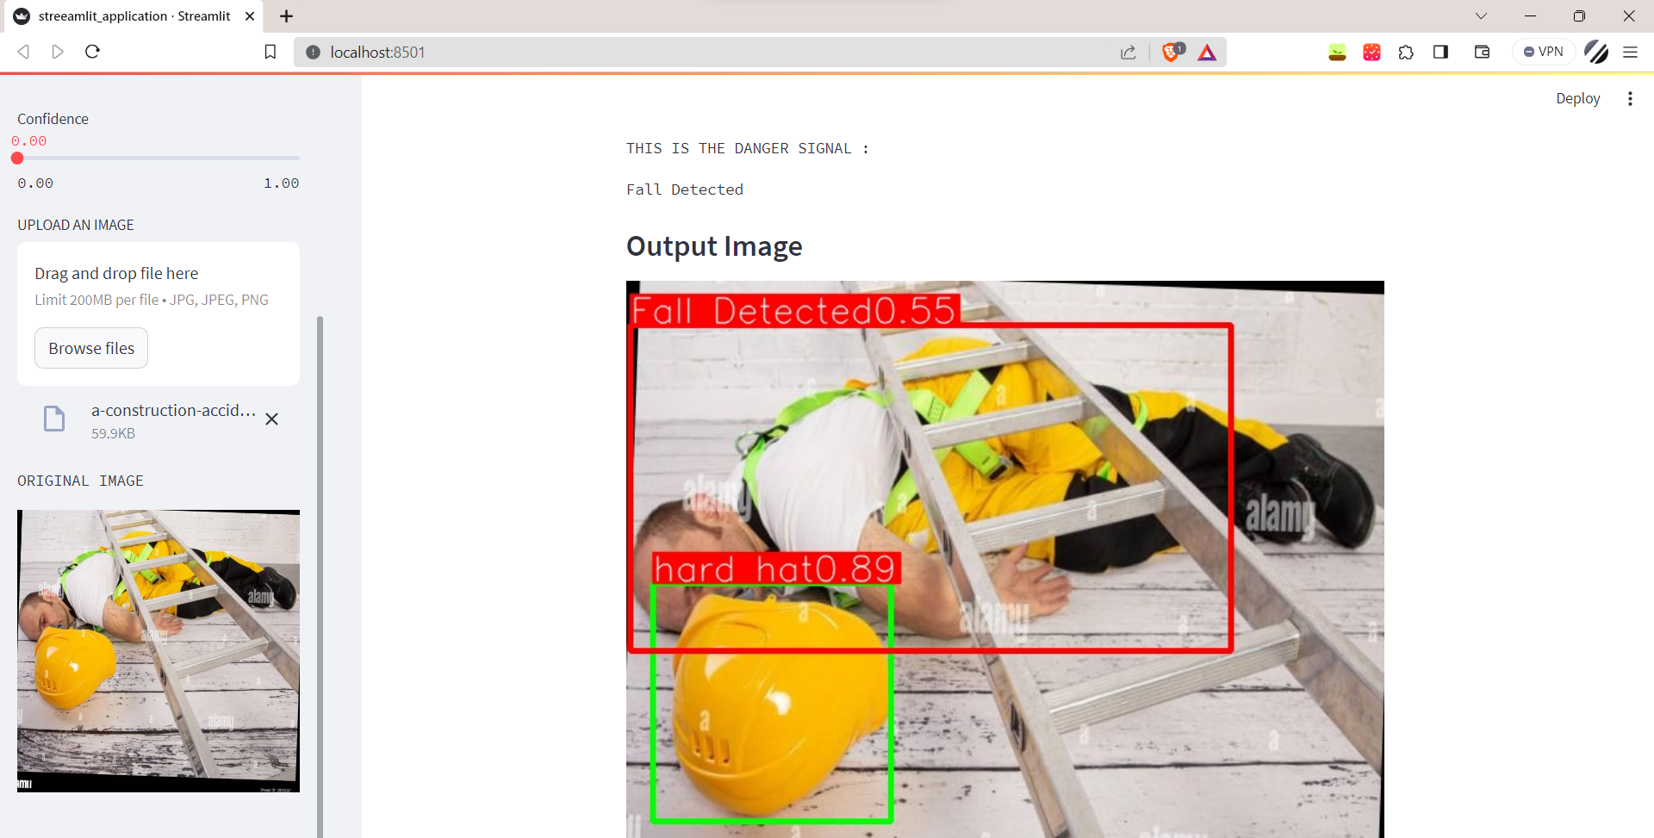

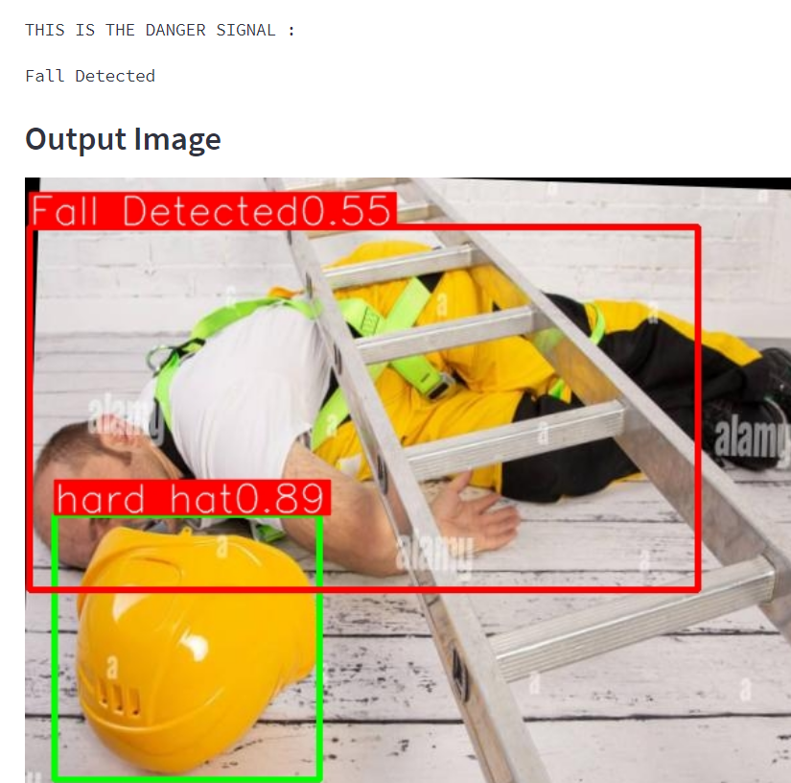

‘Fall detected’ comes under the danger category that is the reason it is red color and the ‘hard hat’ is in green color.

3) **below shown left side is the original image that uploaded into webapp and the output is shown in the middle of the page** 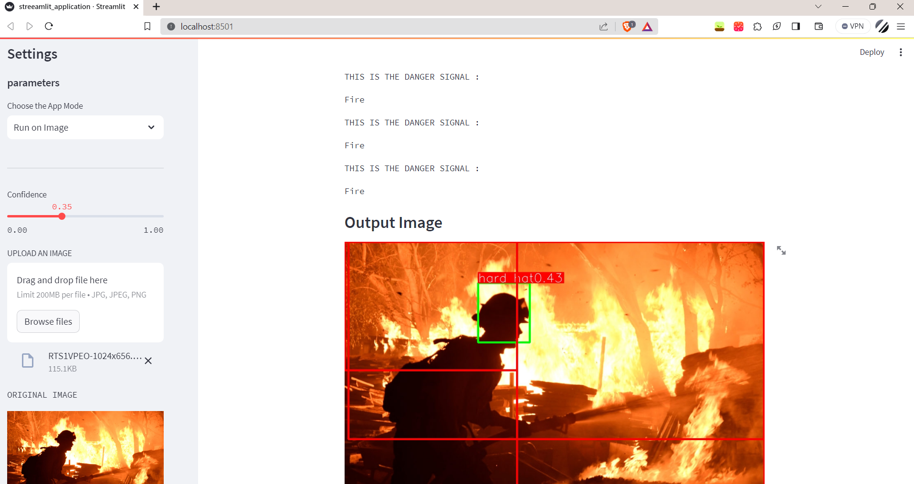

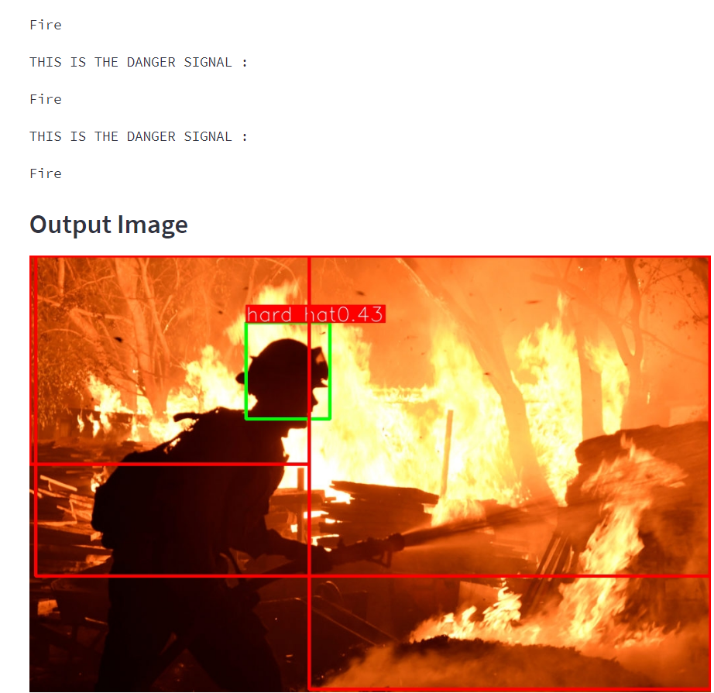

‘Fire’ comes under the danger category that is the reason it is red color and the hard hat is in green color.

**4)** **below shown left side is the original image that uploaded into webapp and the output is shown in the middle of the page** 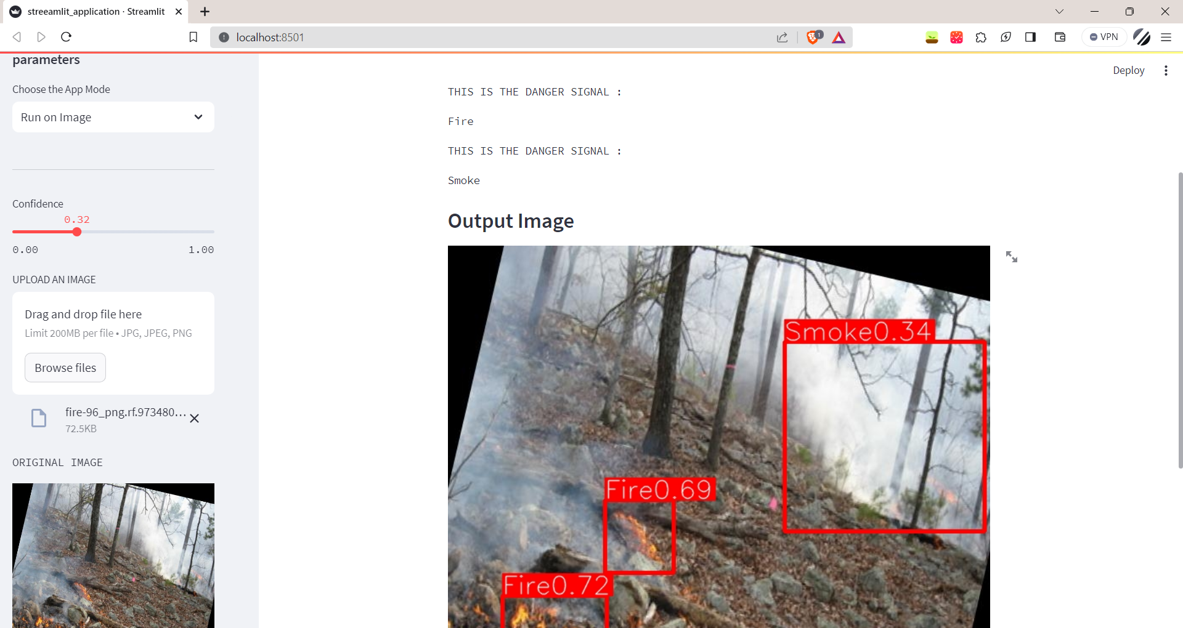

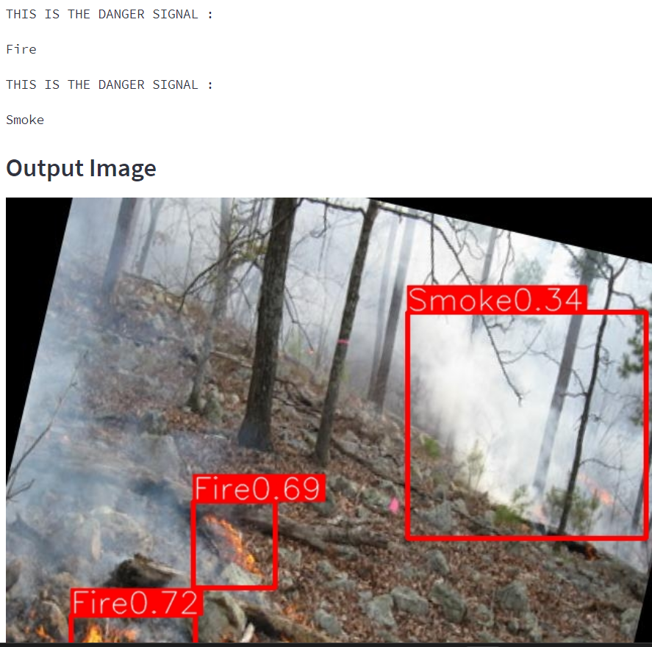

‘Fire’ and ‘smoke’ comes under the danger category that is the reason it is red color.

The final output of the project demonstrates the successful real-time detection of fire, smoke, and fall incidents within industrial settings. A Red Boundary over a situation is given as a danger alert indicator and a Green Boundary is given in Safe conditions.

**\*\*7. ADVANTAGES & DISADVANTAGES\*\***

7.1 Advantages:

- The system operates in real-time, enabling immediate response.

- Enhanced industrial safety by identifying hazards proactively.

- Reduction in the likelihood of accidents through prompt alerts.

7.2 Disadvantages:

- Accuracy depends on the effectiveness of object detection models.

- False positives or negatives may occasionally occur, impacting reliability.

**\*\*8. APPLICATIONS\*\***

The proposed solution can be applied in diverse industrial sectors, including manufacturing, construction, chemical plants, and warehouses. It caters to environments where real-time safety monitoring can prevent accidents and save lives.

**\*\*9. CONCLUSION\*\***

In conclusion, the project demonstrates the feasibility and effectiveness of using machine learning and deep learning for real-time surveillance in industrial environments. By actively identifying hazardous situations and behaviors, the system contributes to creating safer workplaces.

**\*\*10. FUTURE SCOPE\*\***

For future enhancements, the project could:

- Fine-tune object detection models for higher accuracy.

- Integrate with IoT devices to gather additional data sources.

- Investigate predictive analytics to forecast potential accidents.

**\*\*11. BIBLIOGRAPHY\*\***

References:

- Roboflow datasets.

-

**\*\*APPENDIX\*\***

A. Source Code

The attached source code includes the implementation details of the custom YOLO-NAS object detection models used in the project.